6. Access rights
In Linux system, every file or directory is owned by a user and a group. You can get this information by typing “ls –l”
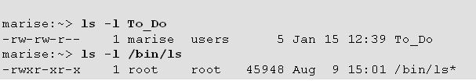
The file To_Do is owned by user marise and group users. The file ls is owned by root and group root
So there are three categories of users for a file or directory:
- the user who is owner of the file or directory
- the users who are not the owner of the file , but are in the same group with owner group
- the users that do not own the file and are in the different group with the file
Every file has three kind of access rights for these three categories of users: read ,write and execute, which are represented by r ,w and x separately. For file To_Do:
- the owner marise can read and write file To_Do
- the user who is not marise but in the group users can read and write file To_Do
- the others can only read file To_Do

  - How to know my username and my group name?
Using id command
The current user name is yang with id number 500. User yang’s current group is yang with group id number 500. User yang is the number of group yang and students.

  - How to change my current group at run time?
Using newgrp command
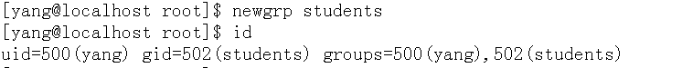

  - How to change my login group?
Vi /etc/passwd, change the group id

  - how to change the owner user and owner group of a file or directory?
Using chown command (only the owner user or root can change this)
#chown student.users /home/user1/file1 #change owner user and owner group
#chown student /home/user1/file1 #change owner user only

  - how to change the file permission of a file
Using chmod command
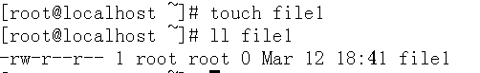
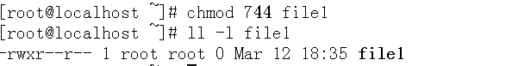
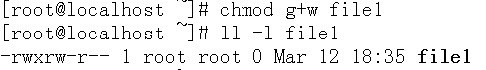
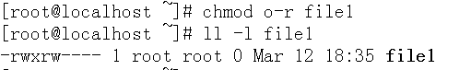
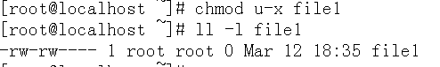

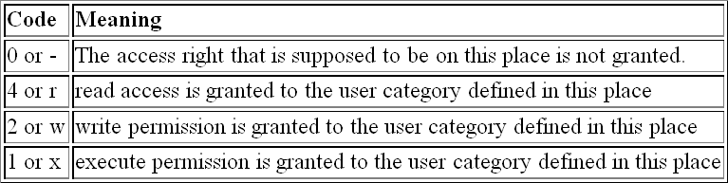

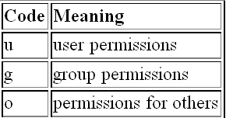

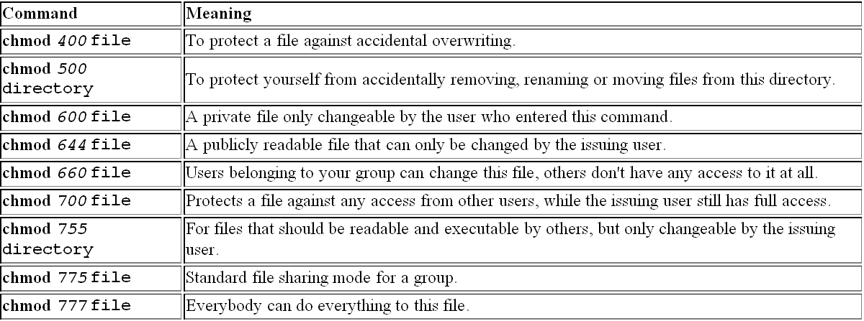

  - Exercise of file access rights
Create two users: user1 and user2
  - user1: create a file /tmp/file1
  - user2: can user2 read /tmp/file1? Can user2 modify /tmp/file1? Can user2 delete /tmp/file1? Why?
  - user1: change /tmp/file1 access rights to 602
  - user2: can user2 read /tmp/file1? Run command “ ls>> /tmp/file1 “ . Can this be successful? Why?
  - user1: change /tmp/file1 access rights to 606
  - user2: can user2 read /tmp/file1? Can user2 modify /tmp/file1? Can user2 delete /tmp/file1? Why?

  - Exercise2 of file access rights
Suppose user1 belongs to group user1 and students, user2 belongs to group user2 and students. Finish following work:
1. root:
(1)vi /tmp/file1 , the content is “hello world”.
(2)change owner of file1 to user1
(3)change owner group of file1 to students
2. user1:
(1) user1 can read and write file1
(2) users that are in students group can read and write file1
(3) others has no rights about file1
3. user2:
Change the content of /tmp/file1 to “hello,linux”

  - What’s the meaning of r,w,x for a directory?
‘r’ means the content of this directory can be read(users can list the content of directory by command “ls” ). ‘w’ means the file and directory can be created in this directory. ‘x’ means this directory can be entered by cd command or can be as a path for a file you want to access
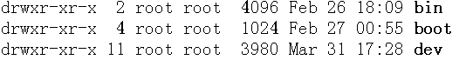
  - Exercise1 about directory access rights
  - user1:
cd /home/user2 ls /home/user2
can these two commands be successful? Why?
  - user2
change /home/user2 access rights to 701
  - user1:
cd /home/user2 ls /home/user2
can these commands be successful? Why?
  - user2
change /home/user2 access rights to 705
  - user1:
cd /home/user2 ls /home/user2 touch /home/user2/f1
can these commands be successful? Why?
  - user2
change /home/user2 access rights to 707
7. user1:
cd /home/user2 ls /home/user2 touch /home/user2/f1
can these commands be successful? Why?
8. user2
change /home/user2 access rights to 703
9. user1:
ls /home/user2 touch /home/user2/f1
can these commands be successful? Why?

  - Exercise2 about directory access rights
suppose user1 belongs to group user1 and students, user2 belongs to group
user2 and students. user3 belongs to group user3 . Finish following work:
- user1 create a directory /tmp/test. The owner group of /tmp/test is students.
- user1 create a new file /tmp/test/file1. The content of file1 is “hello ,teacher”
- user2 can list the content of /tmp/test, but can’t create file in /tmp/test. User2 can read and write /tmp/test/file1
- user3 can not list the content of /tmp/test
- user3 can create file in /tmp/test
- user3 can read /tmp/test/file1 but can not write file1

  - Sticky bit mode
Sticky bit is often applied to directory , for example chmod o+s somedir. If a directory is set sticky bit, a user can not delete file in this directory even if the write permission has been granted to this user. There are three exceptions for this rule:
- This user is the owner of this file
- This user is the owner of the directory
- This user is root
In linux , /tmp is a share directory for all users. The permission of /tmp is following:
Character ‘t’ stands for the sticky bit. Although any user can write in this directory, but you can’t delete file that does not belongs to you except you are root or the file owner.

  - SUID (set user ID) and SGID (set group ID) bit mode
SUID (set user ID) and SGID (set group ID) bit mode are applied to executable file . When this mode is set on an executable file, it will run with the user and group permissions on the file instead of with those of the user issuing the command, thus giving access to system resources.
The passwd is an example of SUID
Character ‘s’ is SUID bit. That means when any use execute passwd he will be granted the right of root because passwd needs to change the file /etc/passwd which is only writable to root.

